40.29: The photon’s energy is 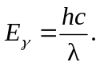
The transition energy is 